2016 RACE TO RENEW- Save My Seats

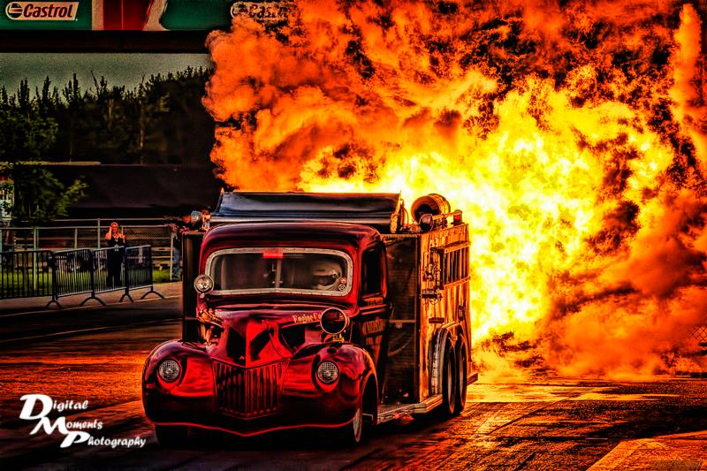





**YOU’VE ASKED- WE’VE ANSWERED**

**NEW FOR 2016: HOT AUGUST NIGHT SAVE MY SEAT**

***Canada’s longest running and largest single day drag event: Hot August Night is the largest Jet Car event in Canada returns Wednesday, August 10, 2016. Each year record breaking crowds can expect to see the skies light up with flames, smoke, and speeds approaching 300MPH. Not only does Hot August Night give us a great big ball of Jet fire, it showcases the best of the best of Western Canada’s extreme motorsports. Nitro Funny Cars, Alcohol Funny Cars, and 200MPH Top Fuel Harleys are just the tip of the iceberg for this fan favorite event.***

***RACE TO RENEW YOUR TICKETS TODAY***

***Valid for Hot Spot VIP, Reserved, and General Admission Seating***

***Want more Reserved Seating? Just ask! 780.461.5801***

Fans who renew by the December 10th cut-off will be able to upgrade and/or relocate their seats during the upgrade and relocation period: December 11-22, 2015.

***The Ultimate Upgrade: Hot Spot VIP Experience***

**Back with More fun and more incredible VIP entertainment.** The All inclusive Event Experience: Members only hospitality lounge access, premium seating, hot catered meal, unlimited beverages, exclusive gifts, private bar service, preferred parking, private autograph sessions, and much more.

QUICK & EASY: SAVE YOUR SEAT ONLINE: <http://castrolraceway.tix.com/renew.asp>.

*You will be prompted for your Order Number and Renewal Code which can be found on the included* ***Race To Renew*** *ordering information below*.

If you are mailing your order in, please print and fill out the bottom portion of this form before sending to the Castrol Raceway office with full payment. You can also contact the Castrol Raceway office directly at anytime (780) 461-5801, to renew your order over the phone or If you would like to upgrade your seats. You must contact the Castrol Raceway office to do so before the December 10, 2015. cutoff date. All upgrades will be processed on a first come-first serve basis.

Thank you for choosing Castrol Raceway as your Place to Play,

Owners & Management, **Castrol Raceway**

If you are mailing in your Save My Seat form to Castrol Raceway, please fill out the payment information below.  
  
**Jeff Hedrick**  
**Order Number: 13551804**  
  
Method of Payment:    VISA    MASTERCARD    CHECK    MONEY ORDER  
  
  
Credit Card #:____________________________   Expiration Date:__________  
  
  
Check #:______________    Amount Paid:______________  
  
If your mailing address has changed or is changing, please notify the Castrol Raceway office.